**Computer Inventory Management System (CIMS) User Manual**

**1. Introduction**

Welcome to the Computer Inventory Management System (CIMS) user manual. This manual is designed to help you navigate and utilize the features of CIMS efficiently. CIMS helps the organization manage its computer inventory, track hardware and software details, and maintain user assignments.

**2. Getting Started**

**2.1 System Requirements**

* A modern web browser (e.g., Google Chrome, Mozilla Firefox, Safari, Edge)
* Internet connection
* User account credentials (provided by the system administrator)

**2.2 Accessing the System**

1. Open your web browser.
2. Enter the CIMS URL provided by your organization.
3. On the login page, enter your username and password.
4. Click the "Login" button.

**3. User Interface Overview**

**3.1 Login page** The login page captures the username and Password.

Enter the provided verification code correctly

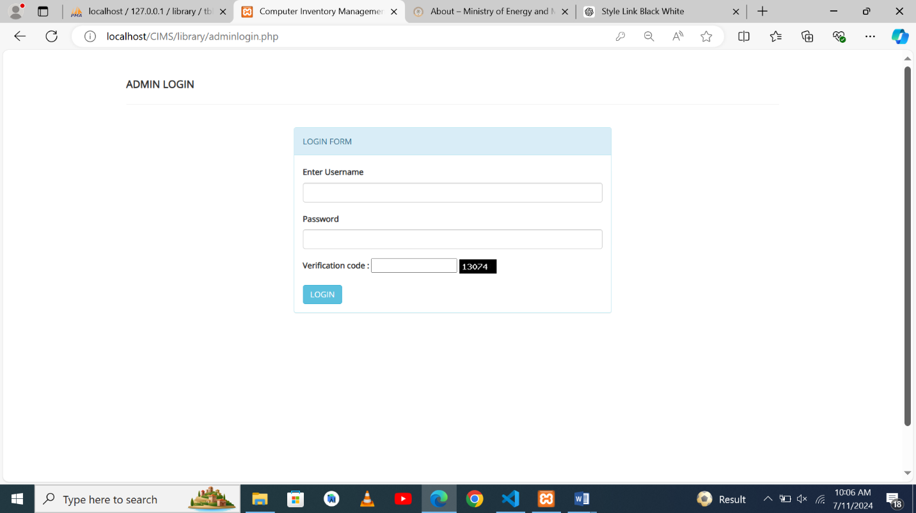

**3.2 Main Dashboard** The main dashboard provides an overview of the system, including:

* Navigation Menu
* Total inventory items
* Faulty items
* Working items

**3.2.1 Navigation Menu** The navigation menu, usually located on the top right side of the screen, includes links to:

* Dashboard
* Categories
* Manufacturer
* Items
* Change Password

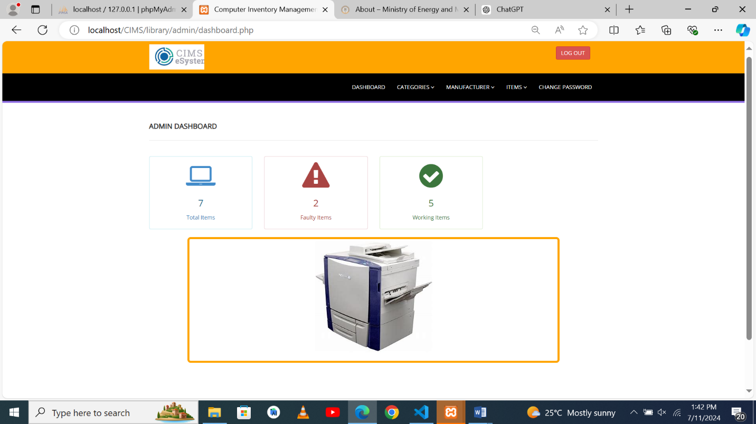

**4. Managing Inventory**

**4.1 Viewing Inventory Items**

1. Click on "Items" in the navigation menu.
2. The inventory list displays all computer items in a table format.
3. Use the search bar to find specific items.

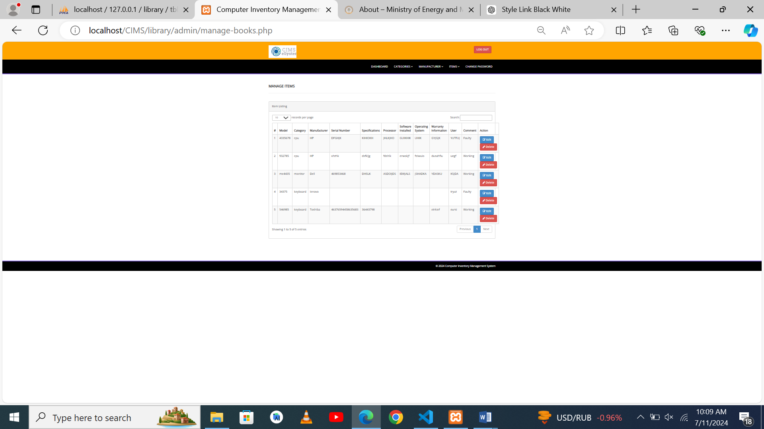

**4.2 Adding a New Inventory Items**

1. Click the "Add Item" button above the “Manage item”.
2. Fill in the details in the form (e.g., Model, Category, Manufacturer, Serial Number, etc.).
3. Click the "ADD" button to add the item to the inventory.

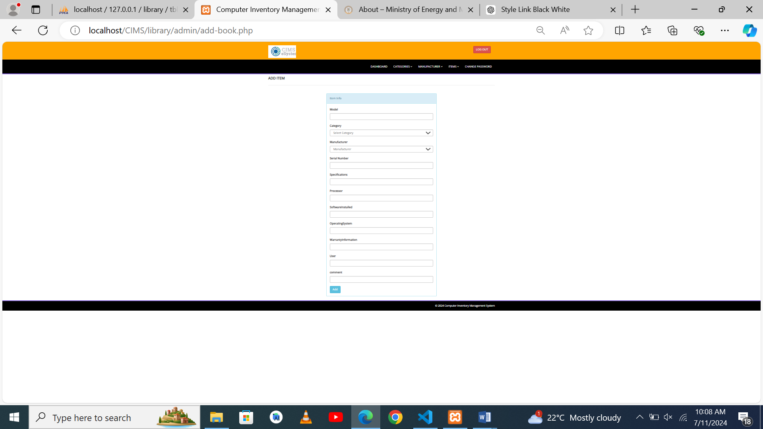

**4.3 Editing an Inventory Item**

1. In the inventory list, find the item you want to edit.
2. Click the "Edit" button next to the item.
3. Update the necessary details in the form.
4. Click the "Save" button to apply the changes.

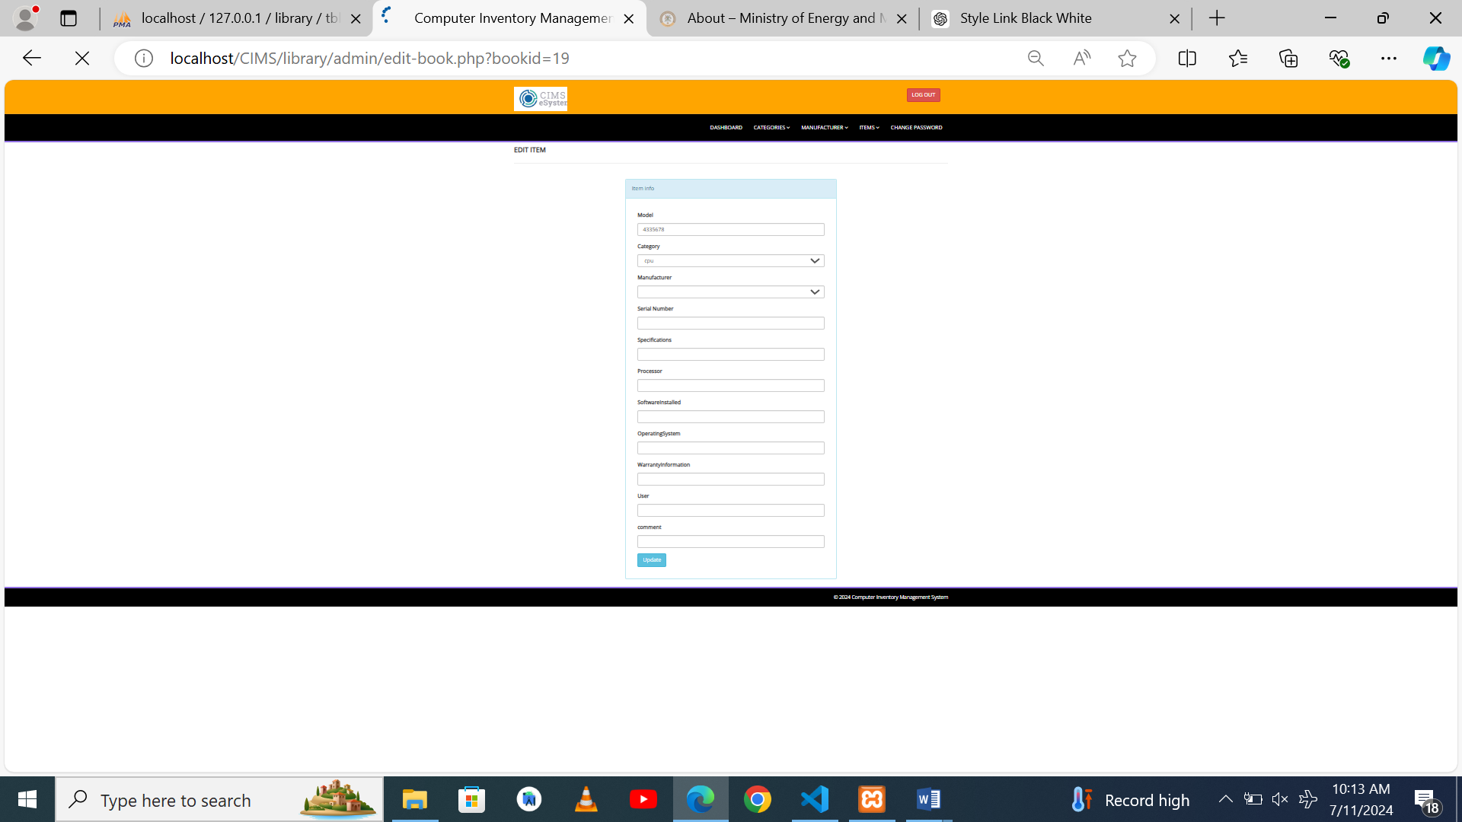

**4.4 Deleting an Inventory Item**

1. In the inventory list, find the item you want to delete.
2. Click the "Delete" button in the last column of the item.
3. Confirm the deletion in the popup dialog.

**5. Troubleshooting**

**Common Issues and Solutions:**

* **Cannot log in:** Ensure you are using the correct username and password. If you forgot your password, use the "Forgot Password" link to reset it.
* Ensure the code is input right
* **Cannot add/edit/delete items:** Ensure you have the necessary permissions. Contact your administrator if the issue persists.
* **System performance issues:** Ensure you have a stable internet connection. If the problem continues, contact the support team.

**6. Support and Contact Information**

For further assistance, please contact the support team at:

* **Email:** [simonbarisigara@gmail.com](mailto:simonbarisigara@gmail.com)

[kirabojellyrollings043@gmail.com](mailto:kirabojellyrollings043@gmail.com)

* **Support Hours:** Monday to Friday, 9 AM to 3 PM (Local Time)

Thank you for using the Computer Inventory Management System. This user manual should help you navigate and utilize the system effectively. For any further questions or issues, do not hesitate to reach out to our support team.